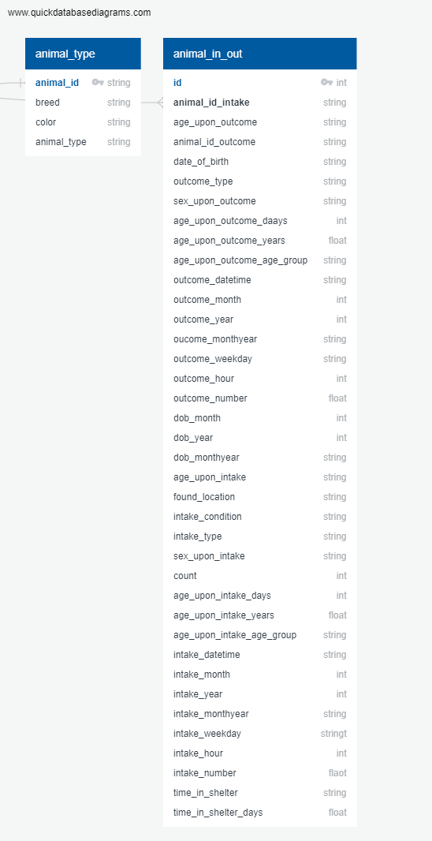

**Database scripts used to add constrains and create objects:**

-- Create a animal_type table to create a master record entry

*Create table animal_type as*

*select distinct animal_id_intake as animal_id, breed, color, animal_type from raw_input_outcome;*

-- Adding primary and foreigh key to existing tables.

*ALTER TABLE animal_type*

*ADD CONSTRAINT animal_id_pk PRIMARY KEY (animal_id);*

*ALTER TABLE animal_in_out*

*ADD CONSTRAINT id_pk PRIMARY KEY (id);*

*ALTER TABLE animal_in_out*

*ADD CONSTRAINT animal_id_intake_fk FOREIGN KEY (animal_id_intake) REFERENCES animal_type (animal_id);*

**Process**:

1. Sheter_db database was created in pg_admin
2. Then using panda’s library created DB connection loaded the raw data into the database.
3. Using SQL Create script created the “animal_type” master object.
4. Finally created a copy of the raw data, performed needed transformation, and created animal_in_out dataset that would be used for analysis.

**Entity Relationship Explanation:**

raw_inout_outcome

This is raw data load to meet the assignment requirement. No changes to the base dataset chosen other than column name update to meet the SQL standards.

One to Many

**animal_type**

This is a copy of raw_input_outcome table after removing breed, color, animal_type and outcome_subtype columns from the original dataset. This will serve as the main operation table to that would capture the variable information collected during intake along with the transformed columns. In a real world, this object would hold input form data and not the transformed columns. For this exercise we will consider this as our object created after the ETL process.

**animal_in_out**

Animal type lookup table. The animal_id in this table is the primary key that will be a foreign key on the operational table. Ex: ***A unique ID that will be assigned based on animal_type, Breed and Color***. For this combination we can have many intake entries that vary on different attributes like (day, time, source, age, etc.